Major Project Final Report on

**Doctor Appointment and Recommendation System (Web Application)**

Submitted in partial fulfillment of the requirements for the degree of

**Bachelors of Engineering in Information Technology**

under Pokhara University

Submitted by:

**Ashbin Thapa, 15455**

Date: 6th May 2023

Under the supervision of  
**Er. Prakash Paudel**

**Department of Information Engineering**

**NEPAL COLLEGE OF**

**INFORMATION TECHNOLOGY**

Balkumari, Lalitpur, Nepal

**SUPERVISOR’S APPROVAL**

This is to clarify that the major project entitled “**Doctor Appointment and Recommendation System (Web Application)**” undertaken and demonstrated by **Ashbin Thapa (15455, BE-IT)** has been successfully completed under my supervision as a partial fulfillment of the requirements for the degree of Bachelor of Engineering in Information Technology under Pokhara University. I, henceforth, approve this project to be awarded the certificate by the concerned authority.

During supervision, I found students hardworking, skilled and ready to undertake any performance work related to this field in future.

**Signature: …………..**

**Er. Prakash Paudel**

**Supervisor**

**Date: 6th May, 2023**

**EXAMINER’S ACCEPTANCE**

This is to clarify that the major project entitled “**Doctor Appointment and Recommendation System (Web Application)**” undertaken and demonstrated by **Ashbin Thapa (15455, BE-IT)** as a partial fulfillment of the requirements for the degree of Bachelor of Engineering in Information Technology under Pokhara University has been examined and accepted by the following panel of experts. we, henceforth, recommend this project to be awarded by the certificate from the concerned authority.

We extend all the best wishes to the students for their future careers.

**Signature: ………….. Signature: ……………**

**Er. Amrit Srivastava Roshan Maharjan**

**Internal Examiner External Examiner**

**Date: 6th May, 2023 Date: 6th May, 2023**

**CERTIFICATE**

Following the supervisor’s Approval and Examiners’ Acceptance, the major project entitled “**Doctor Appointment and Recommendation System (Web Application)**” submitted by **Ashbin Thapa (15455, BE-IT)** as a partial fulfillment of the requirements for the degree of Bachelor of Engineering in Information Technology under Pokhara University, has been officially awarded by this certificate.

I wish the students all the best for their future endeavor.

**Signature: …………..**

**Er. Madan Kadariya**

**Head, Department of Information Technology**

**Date: 6th May, 2023**

**DECLARATION**

I, **Ashbin Thapa (15455, BE-IT),** student of Bachelor of Engineering in Information Technology, Nepal Collage of Information Technology affiliated to Pokhara University, hereby declare that the work undertaken in this major project entitled “**Doctor Appointment and Recommendation System (Web Application)**” is outcome of our own effort and is correct to the best of our knowledge. This work has been accomplished by obeying the engineering ethics; and it contains neither materials published earlier or written by another person/people nor materials which has been accepted for the award of any other degree or diploma of the university or other institution, except where due acknowledgement has been made in the document.

**Signature: …………..**

**Ashbin Thapa**

**Student**

**Date: 6th May, 2023**

**ACKNOWLEDGEMENT**

Without the collaborative efforts of numerous people, this project would not have been feasible. For me, is has been a pleasure to recognize the help and efforts that were crucial and considerate throughout this process. I want to give each of them my deepest appreciation. For the effective completion of this project, I owe a special gratitude to the research that I have cited. Without the help of many people’s knowledge and time, this research titled “**Doctor Appointment and Recommendation System (Web Application)**” would not have been possible. They deserve my special gratitude.

I owe a great deal to my project Supervisor **Er. Prakash Paudel,** an Assistant Professor of Department of Information Technology and Engineering, for his invaluable supervision and guidance throughout the project’s development period as well as for offering technical support and suggestions that allowed my project to develop and grow to the level we hadn’t anticipated in such a short amount of time.

Last, but not the least, I would like to thank my teachers and colleagues who have been knowingly and unknowingly the part of this project and lent support and views during the entire period of development.

**ABSTRACT**

Doctor Appointment and Recommendation System is a web application, which automates the manual system by the help of computerized system that enables patients to schedule appointments with medical professionals. It also helps healthcare provider to manage the information and data for a longer period in a secure and systematic way.

Doctor Appointment and Recommendation System can help to lead an error free, secure, reliable and fast management system. It can assist the user to concentrate on their other activities rather than concentrating on finding doctor. The aim is to automate its existing manual system by the help of computerized equipment and fully functional computer software, fulfilling their requirements, so that their valuable data can be stored for a longer period with easy accessing. The project describes how to manage for good performance and better services for the clients.

The system typically includes a user-friendly interface that allows patients to search for available doctors, choose an appointment time, which suits them. Healthcare professionals can use the system to manage their schedule, access patient information. The use of a doctor appointment system can streamline medical practice and increase patient satisfaction by making it more systematic. The system employs various algorithms and techniques, such as collaborative filtering, content-based filtering, and machine learning, to provide personalized recommendations to patients. The aim of a doctor appointment and recommendation system is to improve patient outcomes by ensuring that patients receive appropriate and high-quality healthcare services. This abstract provides an overview of a doctor appointment and recommendation system and its potential benefits for both patients and healthcare providers.

Keywords: Computerized System, Appointment, Coding, Software Programming, Recommendation

Contents

**1.** **INTRODUCTION** 1

1.1. PROBLEM STATEMENT 1

1.2. OBJECTIVES 2

1.3. PROJECT SCOPE AND LIMITATIONS 2

1.3.1. SCOPE 2

1.3.2. LIMITATIONS 2

1.4. SIGNIFICANCE OF STUDY 3

2.1. PREVIOUS SIMILAR WORKS 4

**3.** **METHODOLOGY** 7

3.1. SOFTWARE DEVELOPMENT LIFE CYCLE 7

3.1.1. REQUIREMENT PHASE 8

3.1.2. ANALYSIS AND DESIGN PHASE 8

3.1.3. IMPLEMENTATION 8

3.1.4. TESTING 8

3.1.5. EVALUATION 8

3.2. WHY ITERATIVE MODEL? 8

3.3. TOOLS USED 9

3.4. TECHNOLOGIES 9

**4.** **WORK DIVISION** 10

**5.** **PROJECT DELIVERABLES** 11

**6.** **PROJECT TASK AND TIME SCHEDULE** 12

6.1. GANTT CHART 13

**7.** **SYSTEM DESIGN AND UML DIAGRAM** 14

7.1. ER DIAGRAM 14

7.2. USE CASE DIAGRAM 15

7.3. DFD DIAGRAM 16

**8.** **PROJECT TESTING** 18

**9.** **CONCLUSION** 20

**10.** **FUTURE WORKS** 21

**11.** **REFERENCE** 22

**12.** **APPENDIX** 23

Screenshots of developed systems 23

**LIST OF TABLES**

Table 1: Tools used 9

Table 2: Work Divisions 10

Table 3: Project Task and Time Schedule 12

Table 4: Project Testing Table 19

**LIST OF FIGURES**

Figure 1: Iterative model of software development life cycle 7

Figure 2: Gantt Chart 13

Figure 3: ER Diagram 14

Figure 4: Use CaseDiagram 15

Figure 5: DFD Level Zero Diagram 16

Figure 6: DFD Level One Diagram 17

# 

# **INTRODUCTION**

The Doctor Appointment and recommendation System is developed to override the problems prevailing in the practicing manual system. This software is supported to eliminate and, in some cases, reduce the hardships faced by this existing system. Moreover, this system is designed for the particular need of the company to carry out operations in a smooth and effective manner.

The application is reduced as much as possible to avoid errors while entering the data. It also provides error message while entering invalid data. No formal knowledge is needed for the user to use this system. Thus, by this all it proves it is user-friendly. Doctor Appointment and Recommendation System, as described above can lead to error free, secure, reliable and fast management system. It can assist the user to concentrate on their other activities rather to concentrate on their other activities rather to concentrate on finding doctor. Thus, it will help organization in better utilization of resources.

Every organization, whether big or small, has challenges to overcome and managing the information of appointment, doctor, booking and doctor schedule

## PROBLEM STATEMENT

The problem that a doctor appointment and recommendation system aim to solve is the inefficient and time-consuming process of scheduling medical appointments.

Traditionally, patients have had to call or visit a medical office to make an appointment, which can be inconvenient and time consuming. Patients also experience long waiting times and have difficulty getting in touch with medical professionals. At the same time, medical professionals face the challenge of managing their busy schedules, tracking patient appointments, and accessing patient information in a timely and accurate manner. The result is a system that can be frustrating for both patients and medical professionals and can lead to decreased patient satisfaction and healthcare outcomes.

A doctor appointment and recommendation system seek to address these issues by providing an efficient and user-friendly platform for scheduling appointments, accessing medical information, and communicating with healthcare providers, ultimately improving the patient experience and enabling better healthcare outcomes.

## OBJECTIVES

The drawbacks mentioned in problem statement needs to be solved, for which a new and easier method for taking appointment is needed to be derived. The main objective of a doctor appointment and recommendation system is to improve patient outcomes by providing personalized recommendations for healthcare providers. Doctor Appointment and Recommendation System is a web application where the patient can book their appointments with their preferred doctors. Similarly, this web application recommends the best doctors for the treatment of the patients as well. Following are the objectives of this project:

1. To develop a web application with admin, patient, and doctor panel,
2. Enhancing patient satisfaction by providing recommendations of doctors,
3. Provides the searching facilities based on various factors such as Doctor, Patient, Booking, Doctor Schedule,
4. Tracks all the information of Appointment and Booking,
5. To increase efficiency of managing the Doctor and Patient,
6. Integration of all records of Doctor Schedule.

## PROJECT SCOPE AND LIMITATIONS

The scope of this project is to provide patient with all the services through a web-based networking service. In this project, a web application will be developed where patient will be able to make an appointment with their desired doctors.

### SCOPE

1. The targeted people are patients.
2. This app can be modified and used for various health sectors.

### LIMITATIONS

1. This is only website not a app.
2. This app is mainly focus to patients.

## SIGNIFICANCE OF STUDY

This project is proposed with the intention to develop a Web Application of the appointment platform where patient can book an appointment for their check-up and get the best doctors. The existing platform provides the appointment platform however; this project will have some additional features regarding the appointments of doctor and recommendation feature. So, this project is meant for providing user-friendly web application in efficient way.

1. **LITERATURE REVIEW**

## PREVIOUS SIMILAR WORKS

**Zocdoc** is an online platform that connects patients with healthcare providers and enables them to book appointments online. It was founded in 2007 and has since become one of the most popular healthcare appointments booking platforms in the US.

Pros:

Convenience: Zocdoc makes it easy for patients to find and book appointments with healthcare providers, without having to call different clinics or hospitals. Patients can view real-time availability of healthcare providers and schedule appointments at their convenience.

Personalized recommendations: Zocdoc provides personalized recommendations for healthcare providers based on patients' location, insurance, and medical needs, making it easier for patients to find the right healthcare provider.

Reviews and ratings: Zocdoc allow patients to leave reviews and ratings for healthcare providers, which can help other patients make informed decisions about which healthcare provider to choose.

Integration with EHR: Zocdoc can be integrated with electronic health records (EHR) systems, which can save time for healthcare providers by eliminating the need for manual data entry.

Cons:

Limited availability: Zocdoc is only available in certain regions of the US, which means that not all patients and healthcare providers can use the platform.

Cost: Zocdoc charges healthcare providers a fee for each booking made through the platform, which can be expensive for smaller clinics and hospitals.

Data privacy: Zocdoc has faced criticism in the past for its data privacy policies, as some patients have reported that their personal information was shared with third-party companies without their consent.

Limited appointment types: Zocdoc is primarily designed for booking appointments with primary care physicians and specialists, and may not be suitable for booking appointments for certain types of medical procedures or tests.

**Healthgrades** is an online platform that allows patients to search for and review healthcare providers based on their specialty, location, and patient reviews. Patients can also book appointments with healthcare providers through the platform.

Pros:

Patient reviews: Healthgrades allows patients to leave reviews and ratings for healthcare providers, which can help other patients make informed decisions about which healthcare provider to choose.

Physician profiles: Healthgrades provides detailed profiles of healthcare providers, including their education, certifications, and specialties, which can help patients choose a healthcare provider who meets their needs.

Telemedicine appointments: Healthgrades allows patients to book telemedicine appointments with healthcare providers, which can be especially helpful for patients who live in remote areas or have difficulty traveling to appointments.

Cons:

Limited appointment availability: While patients can book appointments with healthcare providers through Healthgrades, not all healthcare providers may be available through the platform.

Cost: Healthgrades charges healthcare providers a fee for premium services, which may be expensive for smaller clinics and hospitals.

Data privacy: Healthgrades has faced criticism in the past for its data privacy policies, as some patients have reported that their personal information was shared with third-party companies without their consent.

Inaccurate information: Healthgrades may not always have up-to-date information about healthcare providers, which can lead to inaccurate information being displayed on the platform.

# **METHODOLOGY**

In this section we have described about the method that we will be using to meet the requirement of the project.

## SOFTWARE DEVELOPMENT LIFE CYCLE

The model to be used for developing of this project is Iterative model of SDLC. Iterative model is simple and emphasizes on initial and simple implementation and with progress in the project it gains more feature. It is advantageous since it has unique feature of repetitive nature i.e. during development phase one can go back to check out the previous works without any complications and flaws can be improved if any. Further explanation about the model has been described below.

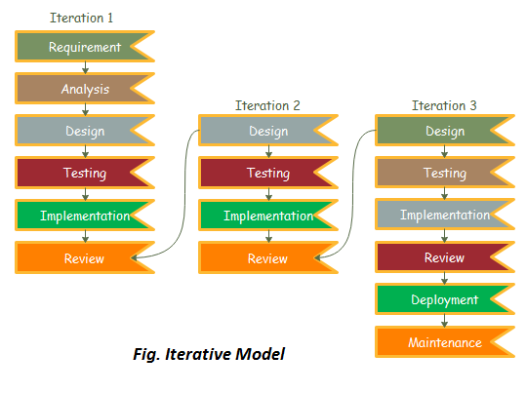

Figure : Iterative model of software development life cycle

### REQUIREMENT PHASE

In this phase, all the necessary requirements are analysed. Till now necessary requirement for further analysis of project is gathered from end-user, Internet and teachers. And as a result, final specification of the project will be gained.

### ANALYSIS AND DESIGN PHASE

In this phase, the specification gathered is designed as per the requirement. Further the database models, technical requirement and the logic will be implemented in the project.

### IMPLEMENTATION

After the analysis and design the coding is done according to the specifications. Coding is in progress and hence a working system will be obtained in this phase.

### TESTING

Once a system is developed series of testing will be performed in order to remove bugs and errors. Also, in this phase certain changes, if necessary, will also be applied to obtain complete and successful system.

### EVALUATION

Evaluation is the last step performed after all the prior steps, where the project will be evaluated to check if it meets the specification or not.

## WHY ITERATIVE MODEL?

Requirements can be changed if necessary by going back to the previous phases without any effect to the further ongoing process.

## TOOLS USED

|  |  |
| --- | --- |
| TOOLS | PURPOSE |
| PHP | Whole application base creation platform |
| GitHub | To manage Source Code |
| Adobe Photoshop CS6 | Logo Design |
| Web Browser | For Testing |

Table 1: Tools used

## TECHNOLOGIES

* Operating system: Windows 8/10/11.
* PHP Programming language for Backend.
* HTML, CSS.
* MYSQL, for database.
* Web Browser.

# **WORK DIVISION**

|  |  |  |  |
| --- | --- | --- | --- |
| SN | NAME | ROLES | RESPONSIBILITIES |
| 1 | Ashbin Thapa | Backend Developer,  Tester,  Documentation Writer,  Frontend Developer,  Project Manager | * Built and maintain database and logic, * Identify and report bugs, ensuring it meets the desired quality, * Create and maintain technical documentation. * Develop and maintain the user facing aspects, * Review and approve project deliverables, * Plan, execute and oversee the development and delivery of the project, ensuring it meets the project requirements, timeline, and budget. |

Table 2: Work Divisions

# **PROJECT DELIVERABLES**

The major goal of our project is to create recommendation system designed to help patients find the right doctors for their healthcare needs. The system would have a database of doctors, patients, and admin, and would use algorithms and data analytics techniques to recommend the most suitable doctors for patients based on their symptoms. Our system will provide the interface for patient, doctor, and admin panel. So, on completion of this project following output will be achieved.

* Admin can manage doctor schedule i.e. addition and deletion of doctor schedule which include doctor fee, hospital, and date and time,
* Admin can add and delete doctor profile,
* Admin can see booked appointment by patient with its pay status and also can delete the appointment,
* Admin can view the details of the patient,
* Doctors can see the booked appointment from the patient and have control to cancel and complete the appointment,
* Doctor can view and cancel their session,
* Doctor can view the patient detail,
* Patient can view the list of all doctors and check if their sessions are available or not,
* Patient can all sessions at once and also can get the recommendation session of the doctors according to the selected symptoms,
* Patient can see their bookings and pay through khalti.

# **PROJECT TASK AND TIME SCHEDULE**

The project schedule has been designed as per requirements of the project. Various tasks have been enlisted in the table as per the requirements. Debugging and testing is to be done prior to the completion of the project. Similarly, approximate duration has been scheduled as per the tasks.

|  |  |
| --- | --- |
| **TASK** | **APPROX** **DURATION IN DAYS** |
|  |  |
| Requirements analysis and specification | 8 |
|  |  |
| Under take analysis of the system | 8 |
|  |  |
| Design system | 14 |
|  |  |
| Produce Requirements specification | 9 |
|  |  |
| Testing and debugging | 8 |
|  |  |
| Test system modules | 4 |
|  |  |
| Overall system test | 5 |
|  |  |
| Develop Documents | 4 |
|  |  |

Table 3: Project Task and Time Schedule

## GANTT CHART

The Gantt chart below has been constructed on the basis of the above project schedule. According to the table the project is estimated to be completed in 3 months. The task is started from preliminary investigations and the other tasks are scheduled in accordance.

|  |  |  |  |  |  |
| --- | --- | --- | --- | --- | --- |
| Month  Task | Feb 2023 | Feb 2023 | March 2023 | March 2023 | April 2023 |
| Requirement Analysis |  |  |  |  |  |
| Analysis of the System |  |  |  |  |  |
| Design System |  |  |  |  |  |
| Procedure Requirement and Coding |  |  |  |  |  |
| Testing and Debugging |  |  |  |  |  |
| Test System Modules |  |  |  |  |  |
| Overall System Test |  |  |  |  |  |
| Develop Documentation |  |  |  |  |  |

Figure 2: Gantt Chart

# **SYSTEM DESIGN AND UML DIAGRAM**

Designing according to the requirement specification, we have tried to make sure that the system actually confirms the user requirements of the system.

## ER DIAGRAM

The ER Diagram is a pictorial representation of the overall logical structure of the system’s database. The ER Diagram of our system is given below. It shows the relationship among the five entities of our system. The entities are represented in the rectangle, their attributes are represented in the oval and the attributes that are underlined are the primary keys.

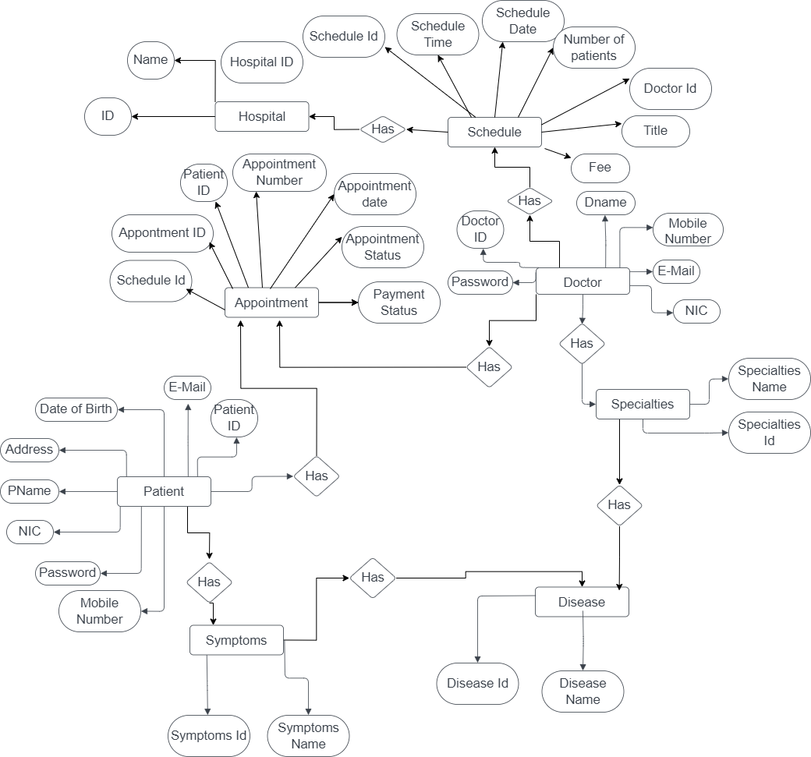

Figure 3: ER DIAGRAM

## USE CASE DIAGRAM

A use case diagram at its simplest is a representation of a user's interaction with the system that shows the relationship between the user and the different use cases in which the user is involved. The actors for our system are: User, System and APIs. The simplified and graphical representation of what our system must actually do is represented below:

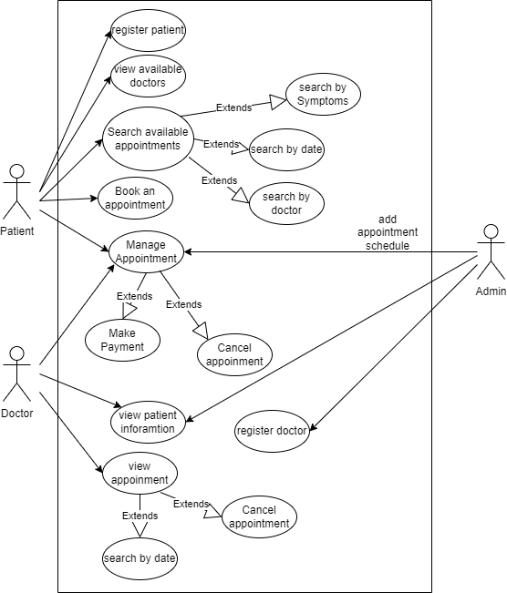

Figure 4: USE CASE DIAGRAM

## DFD DIAGRAM

A data flow diagram (DFD) is a graphical representation of the "flow" of data through an information system, modelling its process aspects. We used DFD as a preliminary step to create an overview of the system, which can later be elaborated also be used for the visualization of data processing (structured design)

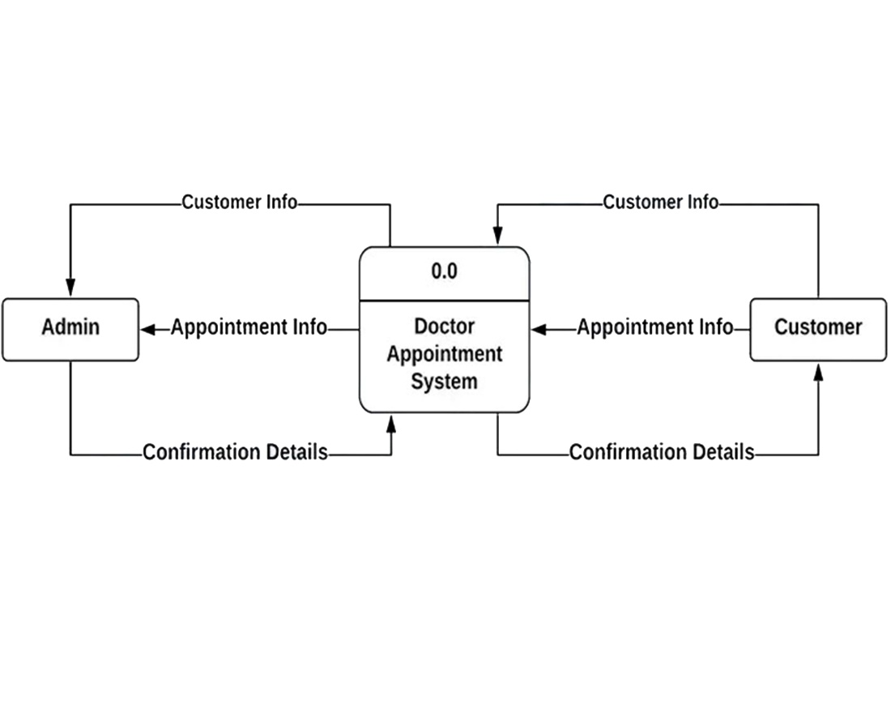

Figure 5: DFD LEVEL ZERO DIAGRAM

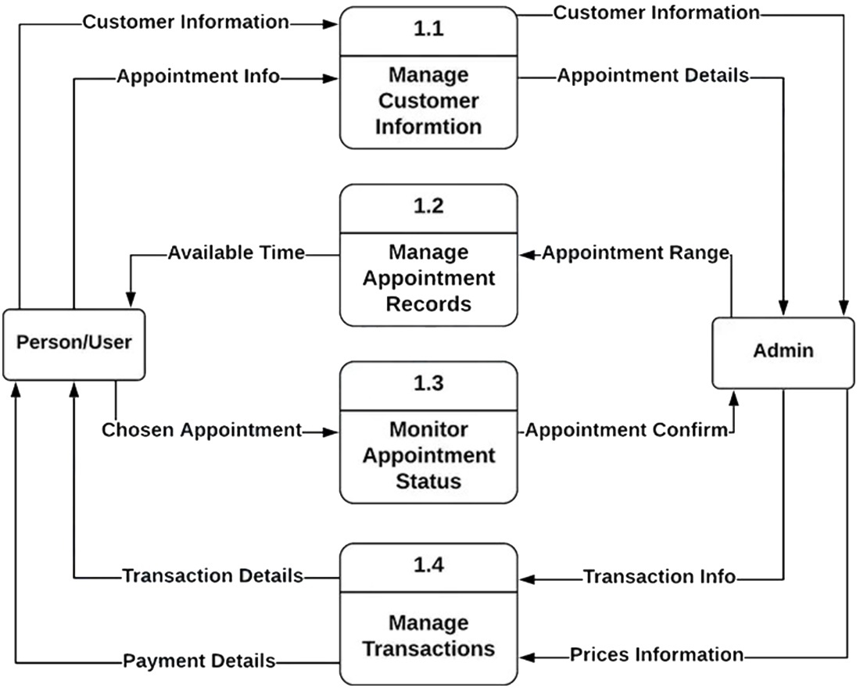

Figure 6: DFD LEVEL ONE DIAGRAM

# **PROJECT TESTING**

To make sure all the elements of our system developed function properly, we created test cases for our work, where validation, reliability and user acceptance were tested.

**Testing Table**

|  |  |  |  |  |
| --- | --- | --- | --- | --- |
| **Test No** | **Unit** | **Test** | **Expected Result** | **Test Outcome** |
| **1** | Layout | Check proper layout for every activity. | Layout of every activity is successfully created | Successful |
| **2** | Register | Register of patient, and doctor. | Patient, and doctor can successfully login. | Successful |
| **3** | Login | Login of admin, patient, and doctor. | Admin, patient, and doctor can successfully login. | Successful |
| **4** | Add and edit doctor | Addition and edit of doctor by admin. | Admin can add and edit doctor. | Successful |
| **5** | Add session | Addition of doctor session by admin. | Admin can add doctor session. | Successful |
| **6** | View of appointment and patient | View of appointment and list of patients. | Admin can view list of appointment and patient registered. | Successful |
| **7** | List of doctors | All doctor views. | Patient can view the list of all doctor with details. | Successful |
| **8** | Recommend by symptoms | Recommend Doctor according to patient selected symptoms. | Patient can get the list of doctors with the available session according to the selected symptoms. | Successful |
| **9** | Payment | Payment of booking. | Patient can make payment by Khalti. | Successful |
| **10** | List of bookings | View of list of bookings by patient. | Patient can view the list of their bookings. | Successful |
| **11** | Cancel and complete booking | Cancel and complete booking by doctor. | Doctor can cancel and compete the booking. | Successful |
| **12** | View of session and cancel session | View and cancellation of session by doctor. | Doctor can view their sessions and can be cancelled by self. | Successful |

Table 4: Project Testing Table

# **CONCLUSION**

In this report, the system allows patient to search doctors according to the symptoms, date and time, and doctors. Doctors, on the other hand, can manage their schedules, view patient information, and update their profiles. The Admin module allows the system administrator to manage doctor and patient information, manage doctor profiles, add doctor sessions and manage sessions.

Overall, the Doctor Recommendation System is an efficient and effective solution for managing healthcare services, improving patient care, and enhancing doctor recommendation. It provides a user-friendly interface for patients, doctors, and administrators to interact with the system and access the information they need. This system can greatly benefit healthcare organizations by increasing their efficiency, improving their service quality, and ultimately leading to better health outcomes for patients.

# **FUTURE WORKS**

The Doctor Recommendation System with Doctor, Patient, and Admin modules is an effective solution for healthcare organizations to manage their processes, provide better patient care, and enhance doctor-patient communication. However, there are several potential areas for future development and improvement that can further enhance the system's capabilities.

One area of future work could be the integration of an AI-powered chatbot that can assist patients with their medical queries and provide them with basic healthcare advice. This chatbot can be designed to understand natural language and use machine learning algorithms to provide more accurate and personalized responses over time. This feature would not only improve patient experience but also reduce the workload on doctors and staff.

Another potential area of development could be the incorporation of telemedicine features into the system. Telemedicine involves the use of technology to provide remote healthcare services, such as virtual consultations, remote monitoring, and remote diagnosis. This feature would greatly benefit patients who live in remote or rural areas, have mobility issues, or need frequent follow-ups. It can also improve the efficiency of healthcare delivery and reduce costs.

The system can be made more accessible and user-friendly by developing mobile applications for patients and doctors. Mobile apps can provide easy access to the system's features, enable notifications and reminders, and facilitate communication between patients and doctors. This would further enhance the system's capabilities and improve patient experience.

# **REFERENCE**

[1] S. Indhumathi, G. vijayabaskar (2015)http://nevonprojects.com/clinic-management-system/.

[2] Quora. Retrieved from The Pros & Cons of using ZocDocAnswers: https://www.quora.com/What-are-the-pros-and-cons-of-using-ZocDoc-to-make-doctor-appointments

[3] Quora. How-much-do-you-value-reviews-ZocDoc-HealthGrades-etc-versus-a-personal-recommendation-when-selecting-a-doctor  
https://www.quora.com/How-much-do-you-value-reviews-ZocDoc-HealthGrades-etc-versus-a-personal-recommendation-when-selecting-a-doctor

[4] 29 May 2021 . Healthgrades application review  
<https://www.apppicker.com/reviews/12416/healthgrades-app-review>

[5] <https://codecanyon.net/item/quick-media-hospitalclinic-management-system/12088123>[.](https://codecanyon.net/item/quick-media-hospitalclinic-management-system/12088123.Accessed%20on%2013/11/2017)

[6]<http://afiinfotech.com/online_clinic_management_system_software>.

# **APPENDIX**

# Screenshots of developed systems

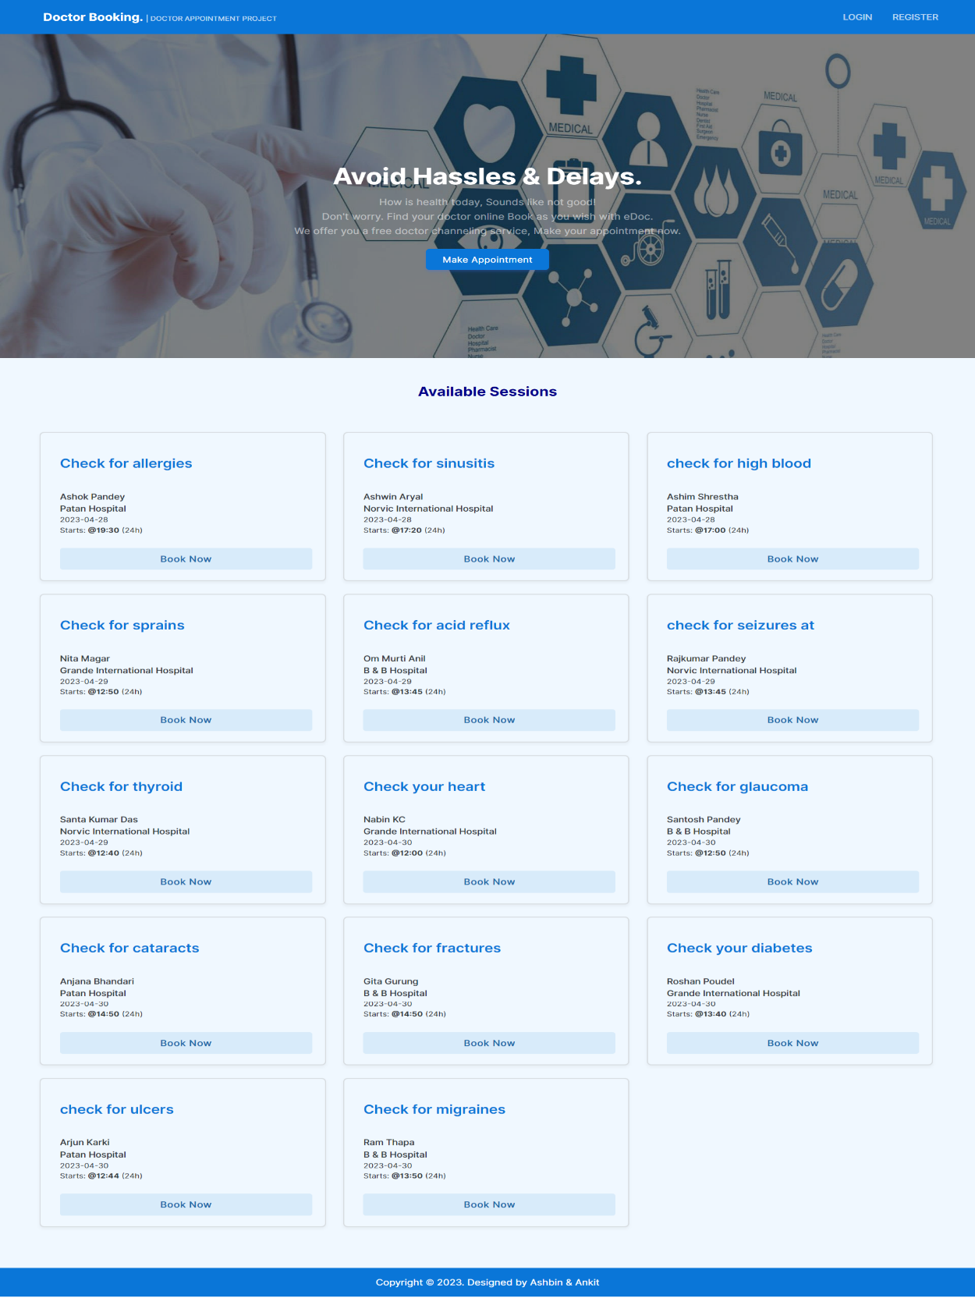

Figure A.1: Home page

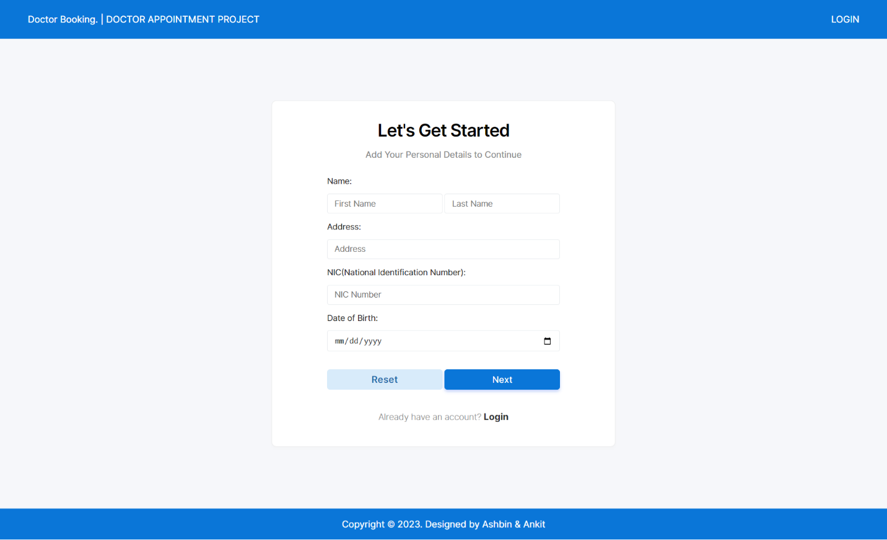

Figure A.2: Sign Up page

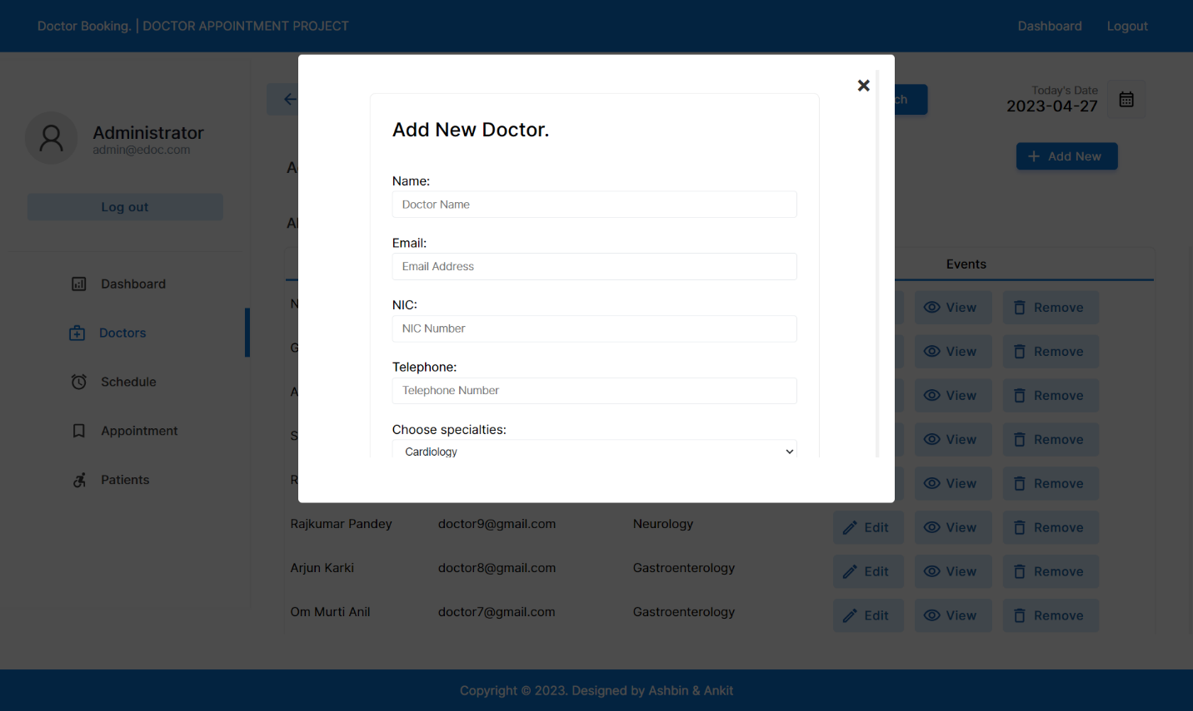

Figure A.3: Add new doctor page

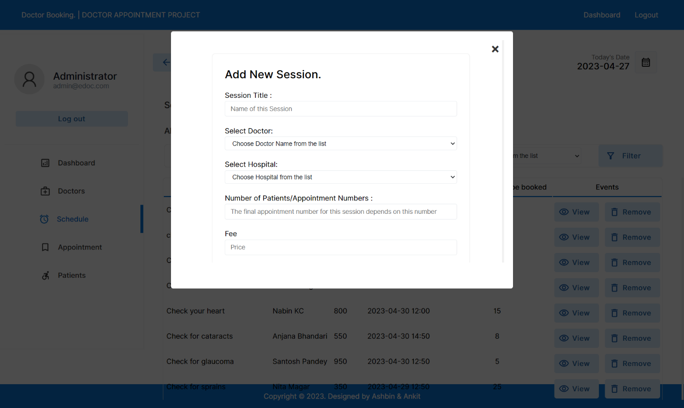

Figure A.4: Add session page

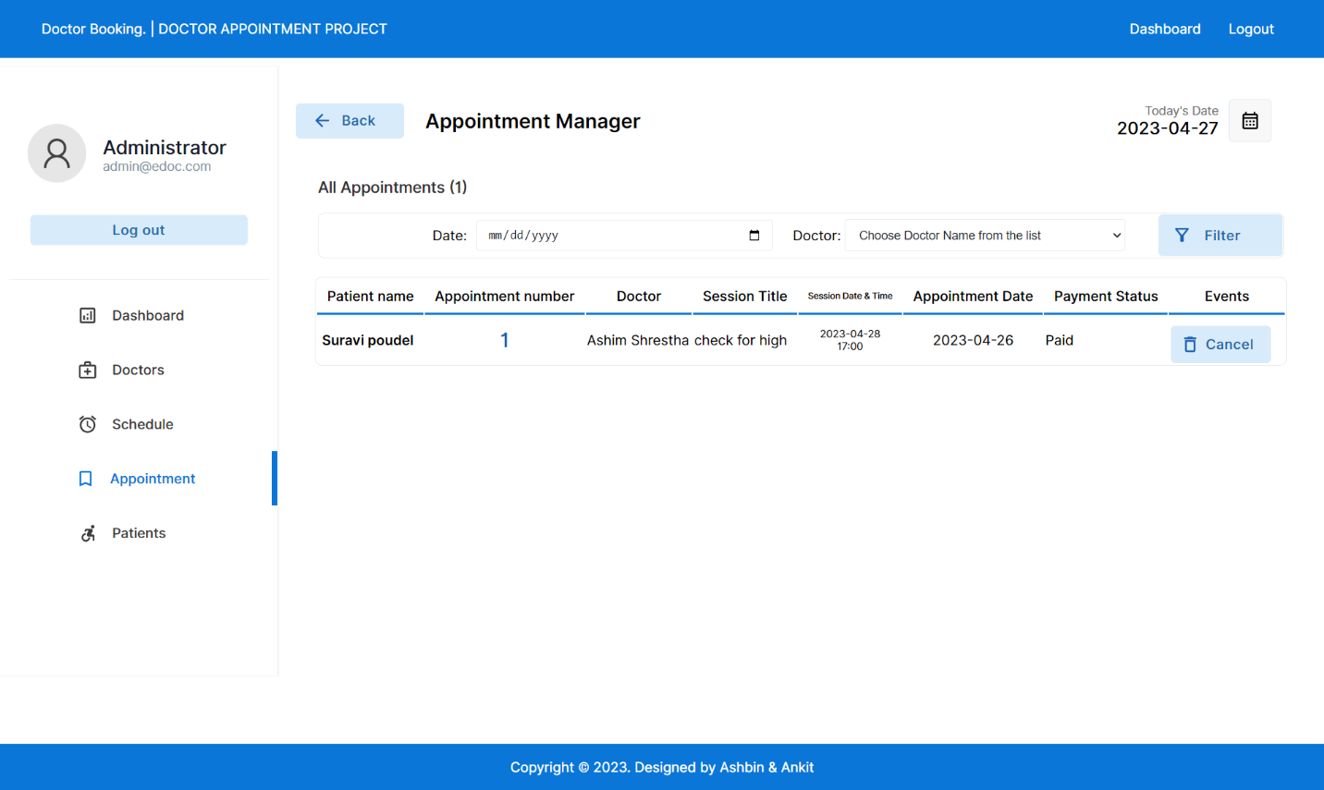

Figure A.5: List of appointments page

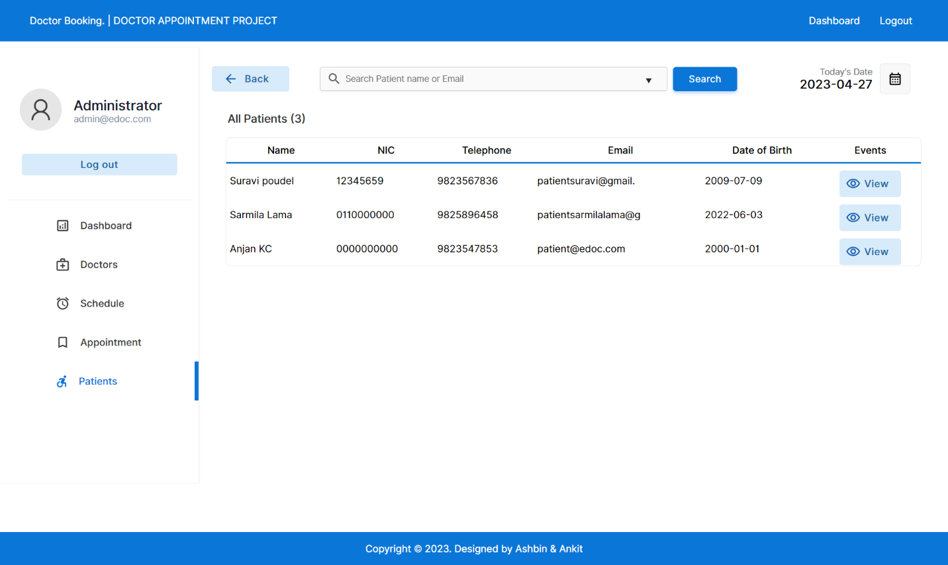

Figure A.6: List of patient page

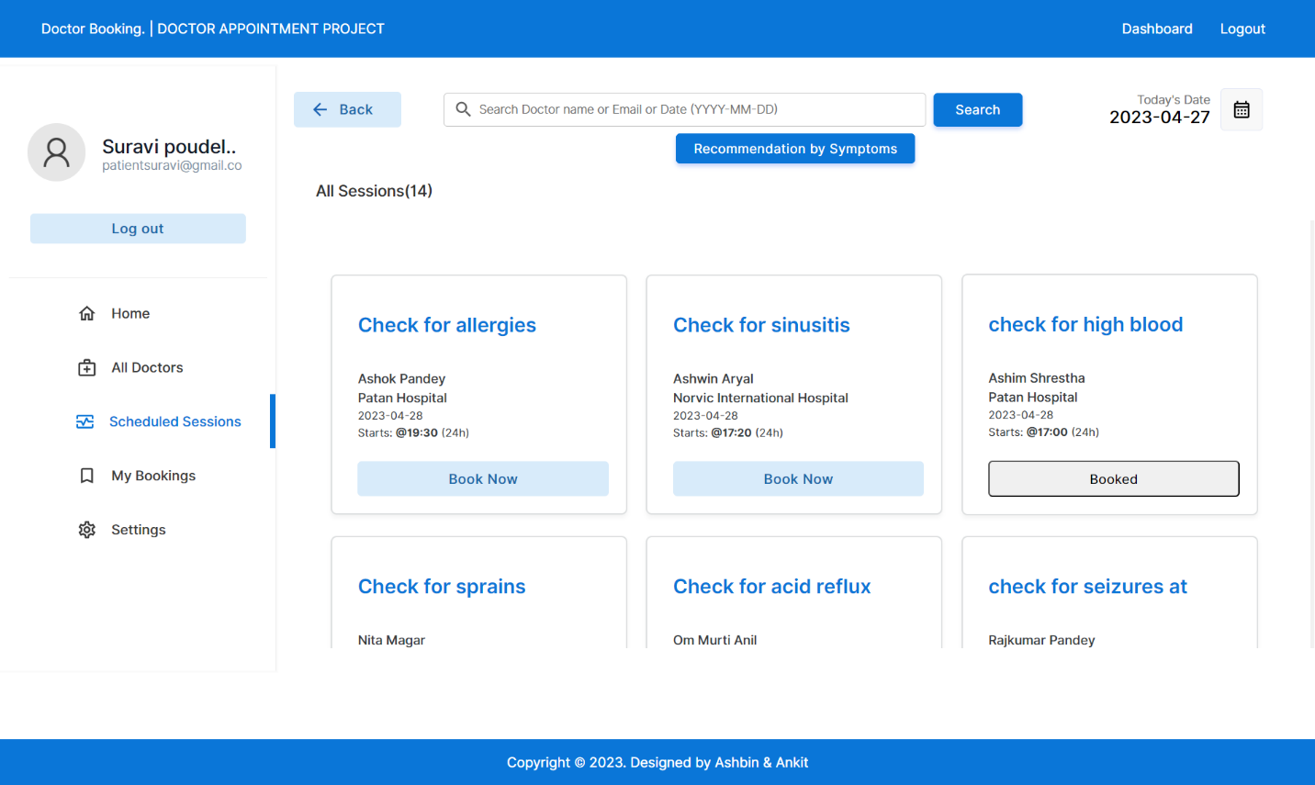

Figure A.7: Schedule session page

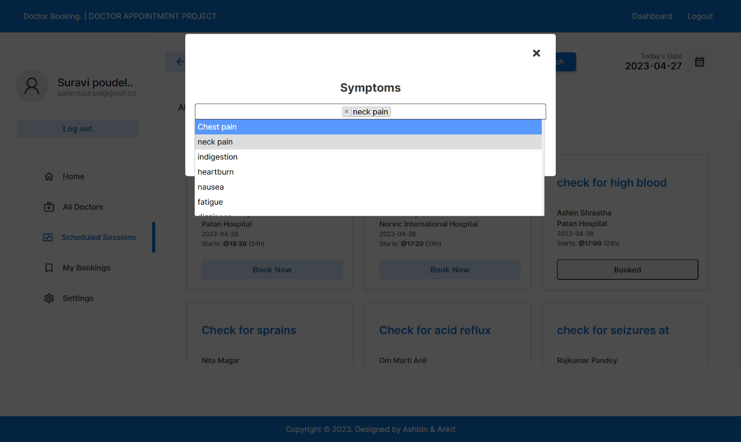

Figure A.8: Recommendation by symptoms page

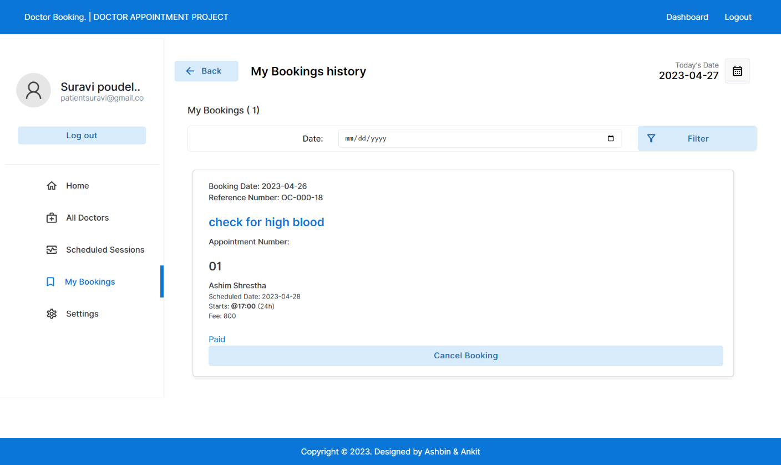

Figure A.9: My bookings page

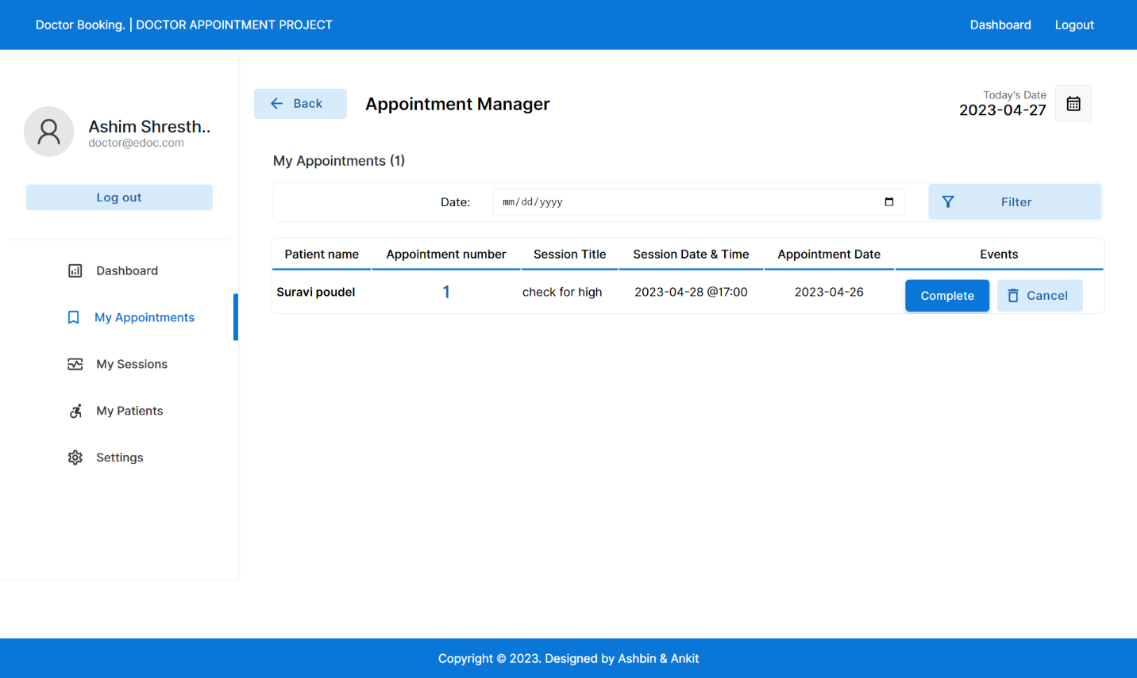

Figure A.10: My appointments page

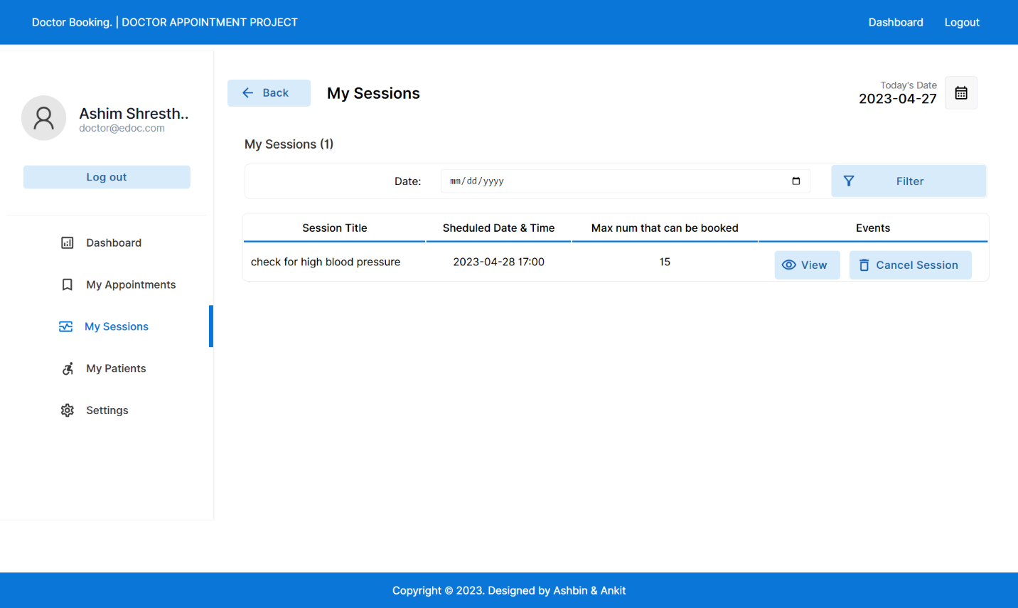

Figure A.11: My sessions page

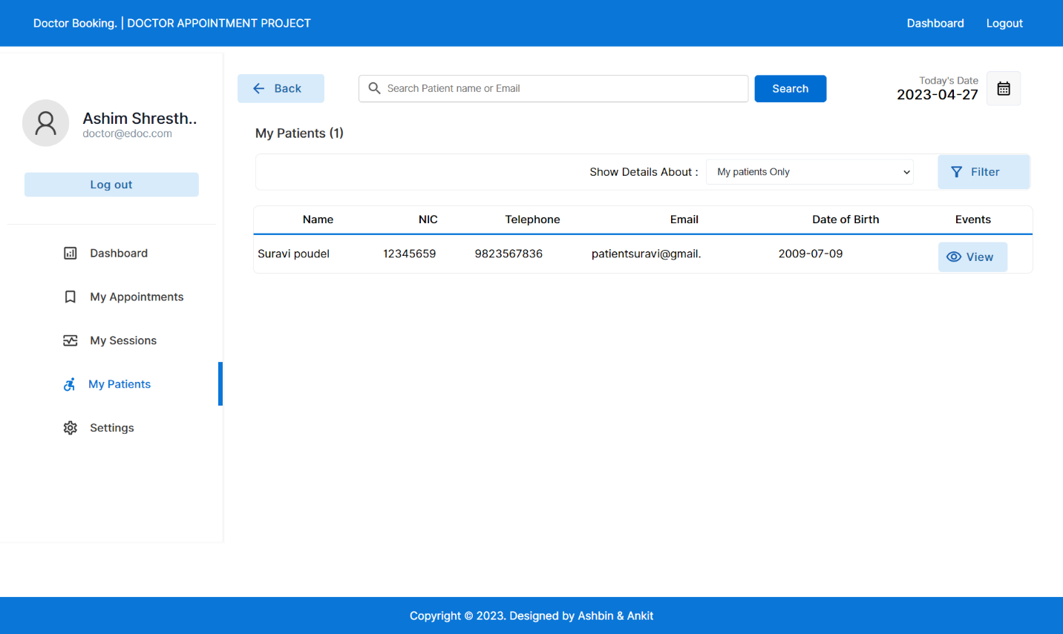

Figure A.12: My patients page

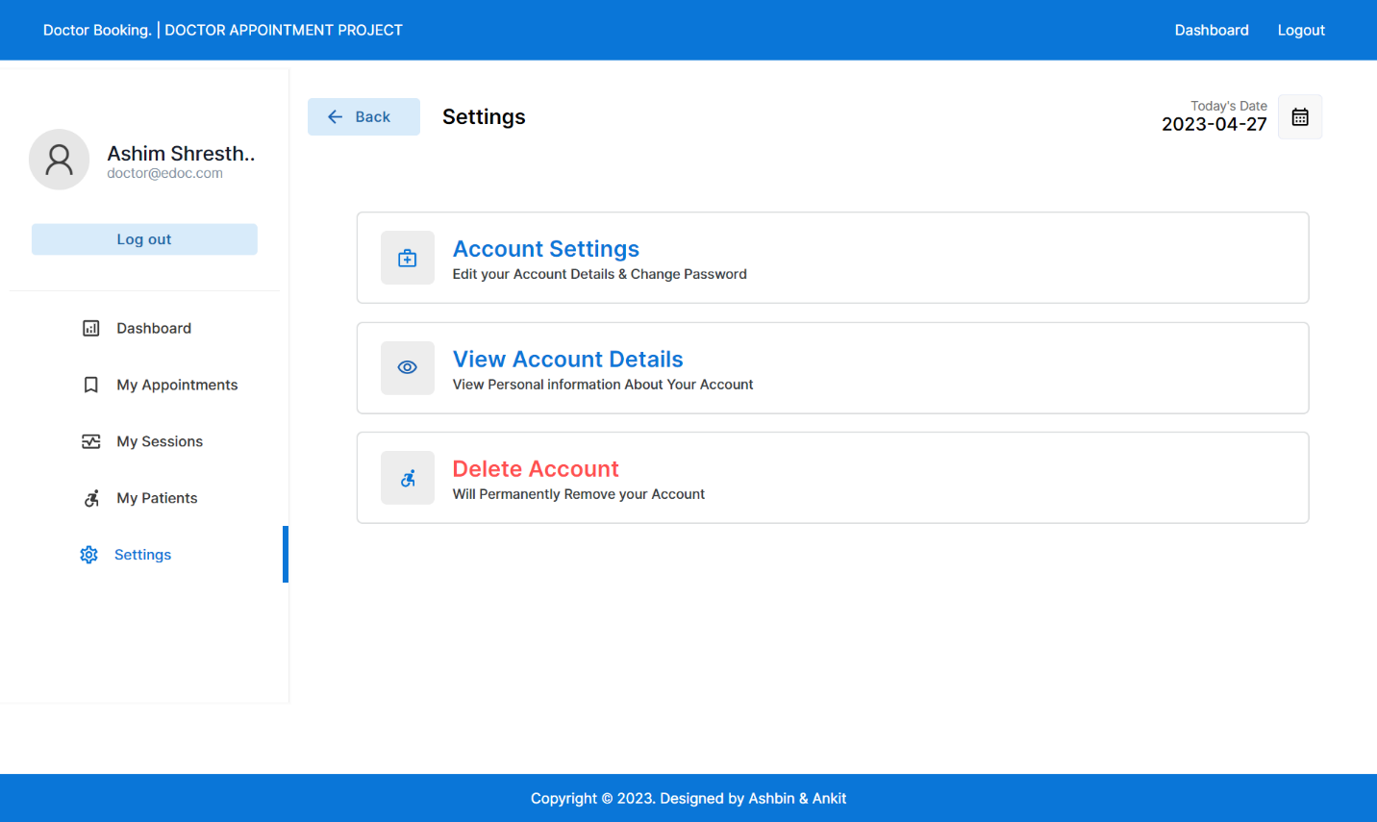

Figure A.12: Settings page